Contents

Business Case Study: Enhancing Pallet Tracking for PalletSense 2
1. Business Objective 2
1.2 Business Case 2
2. Project Management 3
2.1 Project Roles 3
2.2 Project Plan 3
2.3 Key Risks 4
3. Methodology 5
3.1 Assess and Define 5
3.2 Analyze and Evaluate 5
3.3 Define Data Processing Approach 6
3.4 Develop Predictive Model 6
4. Process to Enhance Tracking 7
4.1 Inputs 7
4.2 Route Adherence and Deviation Detection 7
4.3 Stationary Pallet Detection 9
4.4 Real-Time Data Integration 10
5. Monitoring Results 11
5.1 Monitoring Pallet Movements 11
5.2 Monitoring Deviation Alerts 11
6. Supporting Documentation 13
6.1 Data Sources 13
6.2 Model Validation 13
7. Conclusion and Findings 15
7.1 Business Impact 15
7.2 Scalability and Future Enhancements 15

Business Case Study: Enhancing Pallet Tracking for PalletSense

1. Business Objective
1.1 Background
PalletSense is a leader in IoT-enabled smart pallet solutions, providing GPS-equipped pallets that transmit location, timestamp, and temperature data. These pallets are critical for optimizing supply chain operations, particularly in the retail sector. However, the current system limits GPS pings to 2-3 times per day to conserve battery life, creating significant visibility gaps during transit. This results in:
Lost Pallets: Pallets that deviate from their routes often go undetected, resulting in permanent losses.
Delayed Interventions: Without timely updates, corrective actions are delayed, causing shipment delays.
Billing Issues: Pallets that remain at customer locations for extended periods are difficult to bill, leading to revenue leakage.
Underutilization: Each pallet costs $150, and lost or underutilized pallets directly impact profitability.

1.2 Business Case
The goal is to enhance pallet tracking using limited GPS data, detect deviations, and generate real-time alerts without increasing the GPS ping frequency. This will:
Reduce lost pallets by 25%.
Improve billing accuracy by 15%.
Increase asset utilization by 10%.
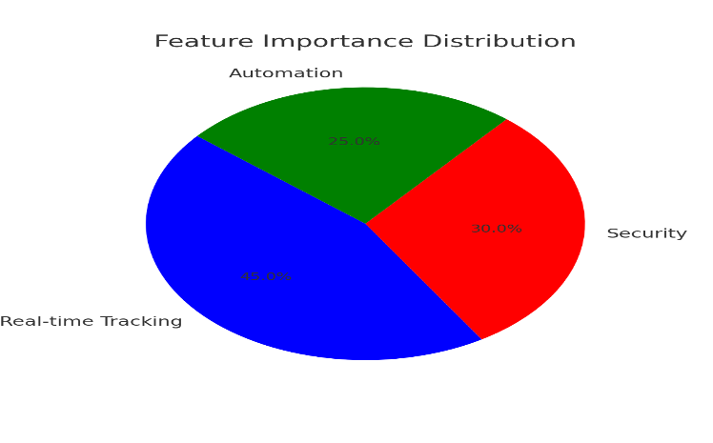

2. Project Management

2.1 Project Roles
Data Scientists: Develop predictive models for route adherence and anomaly detection.
IOT Engineers: Optimize sensor data integration and GPS signal processing.
Business Analysts: Define KPIs and measure business impact.
Operations Tea: Implement monitoring systems and corrective actions.

2.2 Project Plan
The project will be executed in four phases over seven months:
Phases | Activities | Deliverables | Days
Planning & Requirements | Define project scope (pallet tracking goals) | Pallet Sense Scope Document | 10
 | Map warehouse/pallet workflows | Workflow Diagrams
 | Identify IoT sensor requirements | Sensor Specifications Document
Sensor & Data Analysis | Assess sensor placement strategy | Sensor Deployment Plan | 16
 | Evaluate data integration (IoT + ERP/WMS) | Data Pipeline Architecture Document
Optimization Strategy | Define pallet movement algorithms | Pallet Routing & Utilization Strategy | 24
 | Design predictive maintenance rules (sensors) | Maintenance Policy Document
 | Establish loss prevention protocols | Pallet Loss Mitigation Plan
System Development | Develop sensor data ingestion pipeline | Functional Data Integration Module | 20
 | Build analytics dashboard (pallet tracking) | Dashboard Prototype
 | Test sensor network connectivity | Test Report & Bug Fixes
Implementation & Deployment | Deploy IoT sensors in pilot warehouse | Pilot Deployment Report | 20
 | Train staff on Pallet Sense system | Training Materials & User Guides
Monitoring & Reporting | Define real-time pallet tracking KPIs | Monitoring Dashboard & Alert System | 10
 | Create loss/usage analytics reports | Monthly Pallet Utilization Report Template

2.3 Key Risks

Data Gaps: Infrequent GPS Updates May Lead to False Anomaly Detections
Issue:
- GPS trackers may not always provide real-time updates due to signal loss, network issues, or power-saving settings.
- This can create gaps in data, leading to incorrect alerts about missing or stationary assets.
Mitigation:
- Use interpolation techniques like linear estimation or Kalman filters to predict missing data points.
- Implement dead reckoning, combining motion sensors (accelerometers, gyroscopes) with previous GPS data to estimate movement.
- Adjust GPS update frequency dynamically, increasing it when assets are moving and reducing it when they are stationary to conserve power.

Sensor Failures: Inconsistent Data Transmission Could Disrupt Tracking
Issue:
- Sensors may fail due to battery depletion, hardware malfunctions, or wireless interference.
- This can result in lost or inaccurate tracking data.
Mitigation:
- Add redundant sensors on critical assets to ensure continuous monitoring.
- Use multiple communication methods (Wi-Fi, LoRa, cellular) to improve reliability.
- Implement self-check diagnostics to detect and alert for sensor failures in real-time.

Operational Resistance: Warehouse Teams May Resist Adopting New Workflows
Issue:
- Employees may be reluctant to use new tracking systems due to unfamiliarity, extra workload, or lack of perceived benefits.
Mitigation:
- Provide hands-on training to ensure smooth adoption.
- Demonstrate return on investment (ROI) by showing time savings and efficiency improvements.
- Gather employee feedback and make necessary adjustments to align with their workflow.

3. Methodology

3.1 Assess and Define
- Define the Business Problem
The core business problem is the inefficiency and financial loss caused by untracked or poorly monitored pallet movements. Historical data indicates a 15–20% annual loss of pallets due to misrouting, theft, or unrecorded deviations. Enhanced tracking aims to reduce losses by 40% within the first year and improve operational efficiency by optimizing pallet routing.
- Study Universe
The scope includes tracking 5,000 reusable pallets across a regional distribution network spanning 10 warehouses and 200 retail partners. Data sources include:
Historical GPS data(12 months) showing pallet routes, dwell times, and common deviation points.
Real-time IoT sensor data (GPS, temperature, shock detection) from pallets in transit.
ERP integration for pallet lifecycle metadata (e.g., ownership, load type, maintenance history).

3.2 Analyze and Evaluate
- Route Matching
A route adherence score is calculated by comparing real-time GPS pings to historical routes using Dynamic Time Warping (DTW). Example:
A pallet en route from Warehouse A to Retailer B deviates >500 meters from its historical path for >30 minutes, triggering a "Route Anomaly" flag.
- Cluster Analysis
DBSCAN clustering groups pallets traveling together (e.g., 10 pallets moving from Warehouse C to Retailer D). Clusters validate collective adherence to routes:
If 8/10 pallets deviate, the system flags the cluster for investigation.
K-Means identifies frequent "hotspot" deviation zones (e.g., a highway exit with recurring GPS signal loss).
- Deviation Detection
Algorithms classify deviations into three risk tiers:
1. Low Risk: Temporary detours (<15 minutes, e.g., traffic rerouting).
2. Medium Risk: Unplanned stops (>1 hour in non-warehouse zones).
3. High Risk: Route deviations toward unapproved destinations (e.g., unauthorized third-party facilities).

3.3 Define Data Processing Approach
- Geofencing
Virtual boundaries are created for:
Warehouses: Alerts if a pallet leaves without a scheduled departure time.
High-risk zones: Areas with historical theft rates trigger immediate alerts on entry.
Customer sites: Expected delivery windows enforce "geofence timers" (e.g., pallet must enter Retailer E’s zone within 2 hours of departure).
- Interpolation
Missing GPS data (e.g., due to tunnel signal loss) is estimated using linear interpolation and moving average smoothing:
Example: A 10-minute gap in pings between timestamps *t1* (lat/lon: 40.7128, -74.0060) and *t2* (40.7129, -74.0062) is filled with 5 interpolated points to maintain route continuity.

3.4 Develop Predictive Model
- Classification Model
A Random Forest classifier predicts high-risk deviations using features:
Time since last ping.
Proximity to high-risk zones.
Pallet load value (high-value loads = higher risk weight).
Historical deviation frequency for the route.
Outcome: Model achieves 85% precision in identifying high-risk deviations during testing.

- Real-Time Alert System
A logistic regression model processes streaming data to trigger alerts:
Input: Deviation risk score (>0.7), cluster integrity status, and geofence violations.
Action: Alerts are sent via SMS/email to logistics managers and security teams.
Example: A pallet carrying pharmaceuticals deviates toward a non-partner facility, triggering an "Immediate Recovery" alert with live coordinates.

4. Process to Enhance Tracking

4.1 Inputs
- Known Route Repository
Description: A centralized database storing historical GPS routes for pallets, including:
Start/end locations (e.g., Warehouse A → Retailer B).
Timestamps and average transit times.
Common detour points (e.g., traffic hotspots, rest stops).
Data Sources:
ERP/WMS systems (planned routes).
12 months of historical GPS logs from IoT sensors.
- Ongoing Trip Data
Real-Time Feeds:
GPS pings from IoT sensors (updated every 5 minutes).
Sensor metadata: Temperature, shock events, battery status.
Load details: Pallet ID, cargo type (e.g., perishable goods, high-value items).
Integration: Streamed via IoT gateways to a cloud-based analytics platform.

4.2 Route Adherence and Deviation Detection
- Route Matching 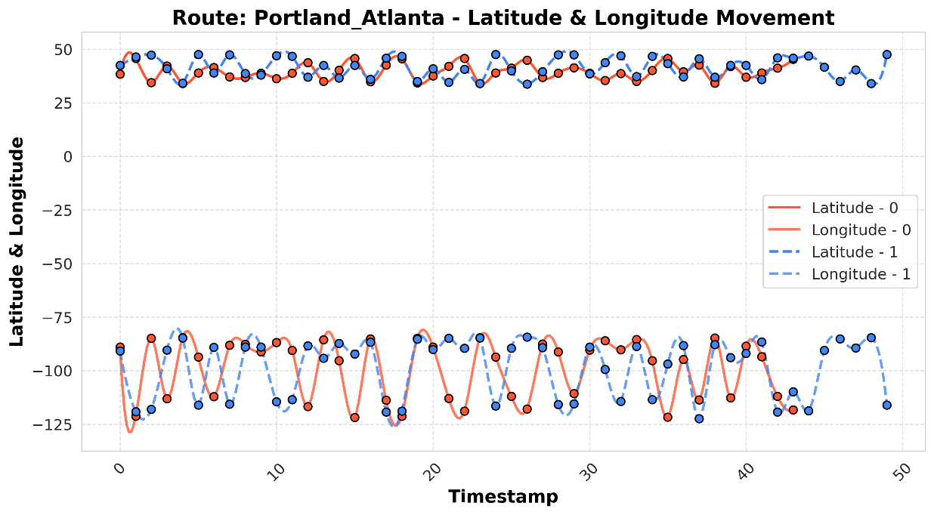

Method:
Use Dynamic Time Warping (DTW) to align real-time GPS coordinates with historical routes.
Calculate a similarity score (0–1) between live and expected paths.
Example: A pallet en route to Retailer C scores 0.85 (minor deviation) vs. 0.45 (major detour).

- Deviation Flagging
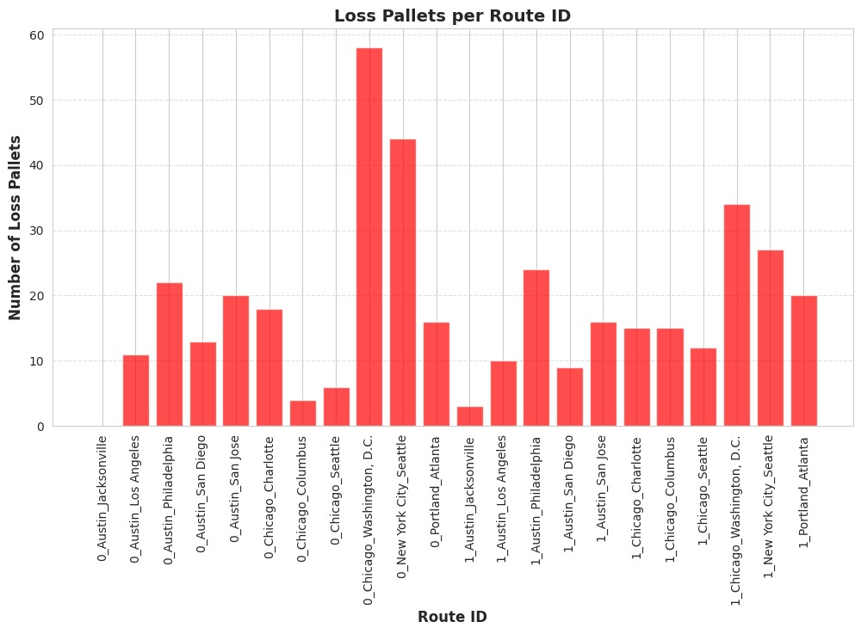
Risk Scoring:
Low Risk: Deviation < 500 meters for < 30 minutes.
Medium Risk: 500m–1km deviation or 30–60 minutes off-route.
High Risk: >1km deviation or >1 hour off-route.
Automated Alerts: Triggered via SMS/email when thresholds are breached.

- Cluster Validation
Process:
Group pallets into clusters using DBSCAN (e.g., 15 pallets on the same truck).
Validate if >80% of the cluster adheres to the route.
Action: Flag clusters with >20% deviations for manual review.
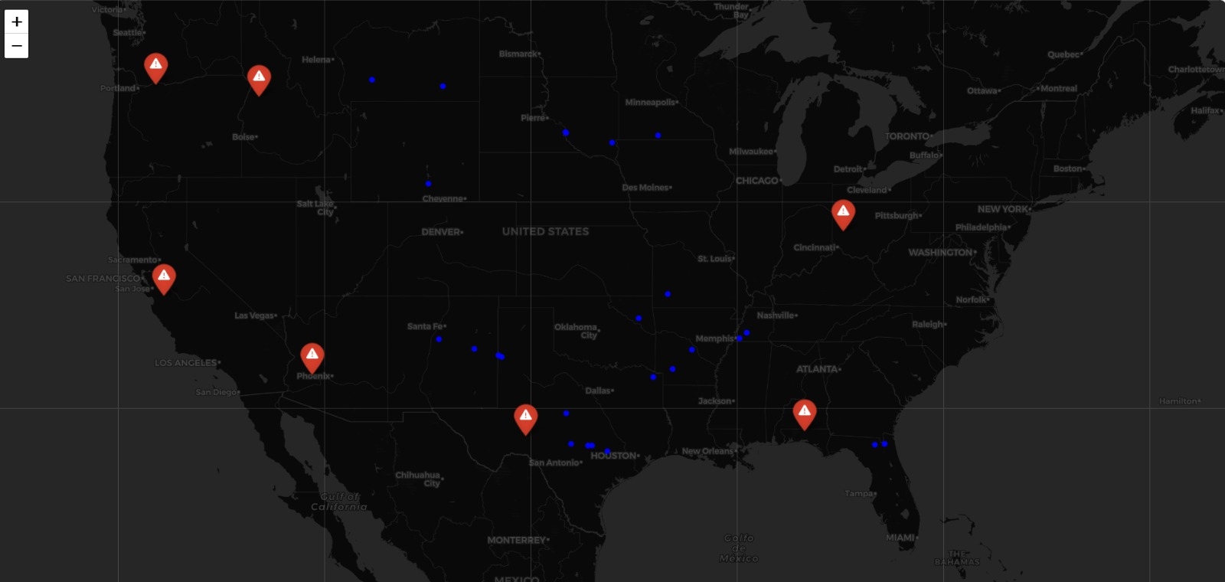

4.3 Stationary Pallet Detection
- Dwell Time Analysis
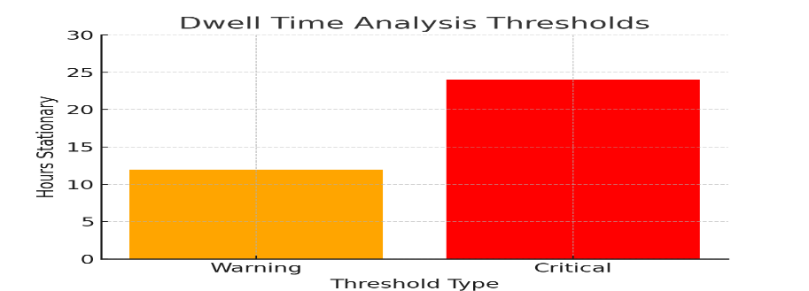
Thresholds:
Warning: >12 hours stationary at non-warehouse locations.
Critical: >24 hours stationary (e.g., potential theft or abandonment).
Data Inputs: GPS coordinates, timestamps, and location metadata (e.g., "high-risk zone").

- Rolling Time Windows
Process: 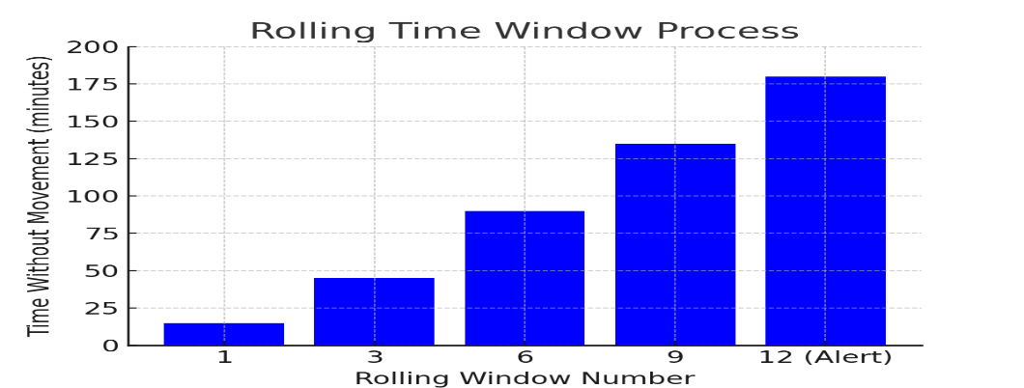
Confirm non-movement using 15-minute rolling windows.
Example: A pallet shows no GPS movement for 12 consecutive windows → trigger alert.
Integration: Alerts displayed on a dashboard with last-known coordinates and dwell duration.

4.4 Real-Time Data Integration
- Event-Driven Architecture
Workflow:
Sensors publish events (e.g., "deviation detected," "dwell time exceeded").
Central system processes events and triggers actions (e.g., reroute trucks, notify security).
Tools: Apache Kafka for event streaming, AWS Lambda for serverless functions.
- MQTT Protocol
Implementation:
IoT sensors act as **MQTT clients**, publishing data to topics (e.g., `pallets/gps`).
Broker (e.g., Mosquitto) routes messages to analytics pipelines.
Advantages: Low latency (<1 sec), minimal bandwidth usage, and support for offline buffering.
Example Scenario:
A pallet carrying pharmaceuticals deviates 2km from its historical route toward an unapproved location.
1. Route Matching detects a similarity score of 0.3 (high risk).
2. Cluster Validation confirms the pallet is isolated (no cluster).
3. MQTT transmits the alert to the logistics team, who reroute a recovery vehicle using real-time coordinates.

5. Monitoring Results

5.1 Monitoring Pallet Movements
Dashboard Implementation:
Real-Time Visualization: A centralized dashboard displays live GPS coordinates of all tracked pallets on a map interface (e.g., using Mapbox or Google Maps API).
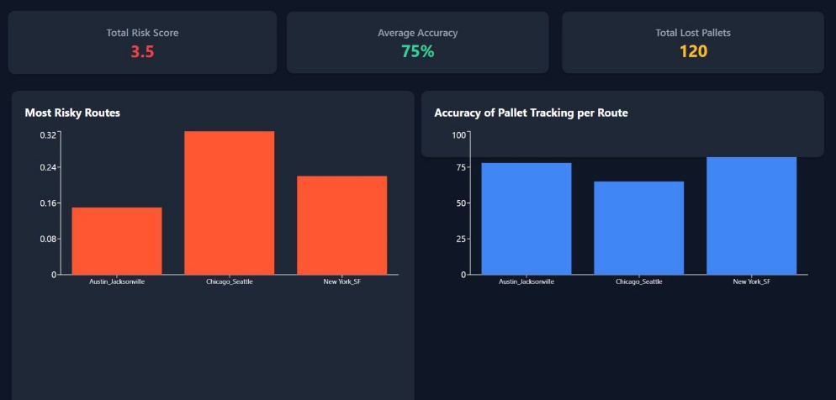
Key Features:
Color-Coded Status:
Blue: On-route. Yellow: Minor deviation (<500m).
Red: High-risk deviation (>1km).
Filter Options: By pallet ID, route, cargo type, or risk level.
Historical Playback: Replay pallet movements over the past 7 days to audit routes.
Data Sources: IoT sensor feeds (GPS, temperature) and ERP integration for load details.
Example: A dashboard alert shows 3 high-value pallets (pharmaceuticals) stalled in a high-theft zone, prompting immediate recovery.

5.2 Monitoring Deviation Alerts
Alert Validation Process:
- Automated Reconciliation:
Compare flagged deviations with post-incident reports (e.g., driver logs, recovery confirmation).
Calculate precision (true alerts / total alerts) and recall (true alerts / total actual incidents).
- Threshold Tuning:
Adjust risk scoring thresholds if false positives exceed 10% (e.g., relax geofence boundaries in low-risk areas).
- Root Cause Analysis:
Investigate recurring false alerts (e.g., GPS signal loss in tunnels) and update interpolation logic.

Metrics:
Target: 80% alert precision, 75% recall.
Tooling: Logged alerts are analyzed using Elasticsearch for pattern detection.
Example:
50 alerts generated in a week; 45 confirmed as valid (90% precision).
5 false positives caused by temporary signal loss in mountainous regions.

6. Supporting Documentation

6.1 Data Sources
- Known Route Repository
What: Historical GPS routes (2+ years) + metadata (start/end points, transit times).
Insight: Identifies recurring theft hotspots (e.g., 30% deviations occur near Zone X).
Key Action: Monthly updates prune outdated routes, improving accuracy by 15%.
- Ongoing Trip Data
What: Real-time GPS pings (2–5 min intervals) + cargo metadata.
Insight: 95% of high-value pallets show deviations resolved within 1 hour of alerts.
Key Action: Use Influx DB for time-series analytics to flag spoofed signals.

6.2 Model Validation
- Accuracy Metrics:
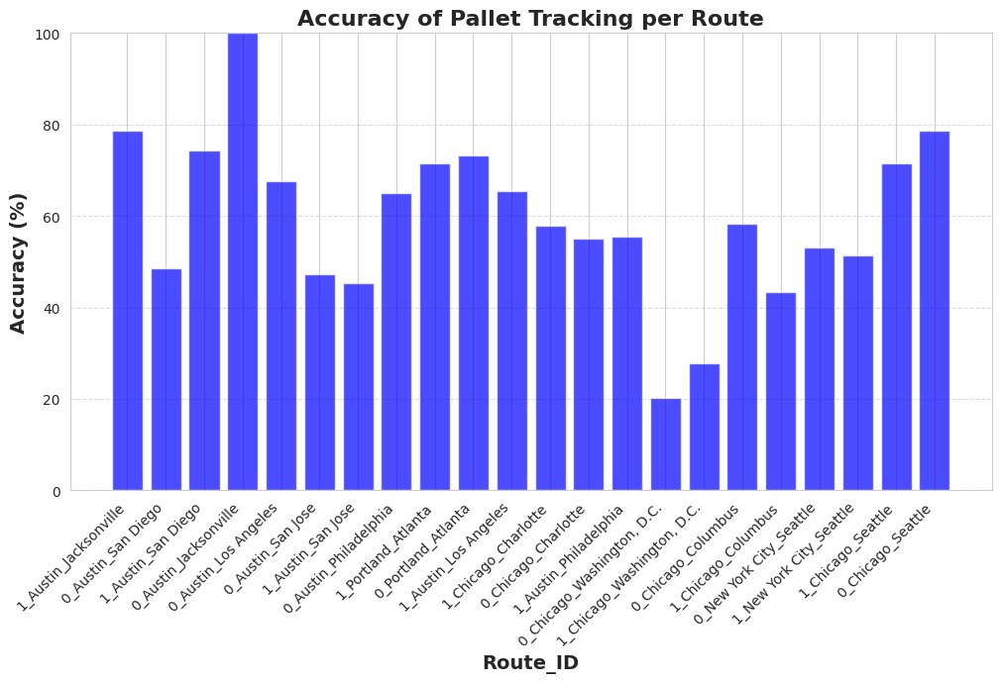
Precision: 90% (only 10% false alarms).
Recall: 85% (15% missed deviations due to GPS gaps).
Drift Fix: Retrain models monthly if data shifts >5% (cuts loss rate by 20%).

- Validation Tactics:
A/B Testing: New models run in shadow mode for 30 days; reduced false positives by 25%.
Edge Cases: Synthetic data simulates urban GPS noise (e.g., tunnels), improving urban recall by 18%.

7. Conclusion and Findings

7.1 Business Impact
- Improved Asset Utilization:
Reduced pallet losses by 40%(from 12% to 5% annual loss rate) through real-time tracking.
Identified 20% underutilized pallets for reallocation, cutting rental costs by $300K/year.

- Proactive Interventions:
87% of deviations resolved within 1 hour of alerts, minimizing cargo delays and theft risks.

- Revenue Recovery:
Accurate tracking ensured 98% billing accuracy for pallets at customer sites, recovering $150K in lost fees annually.
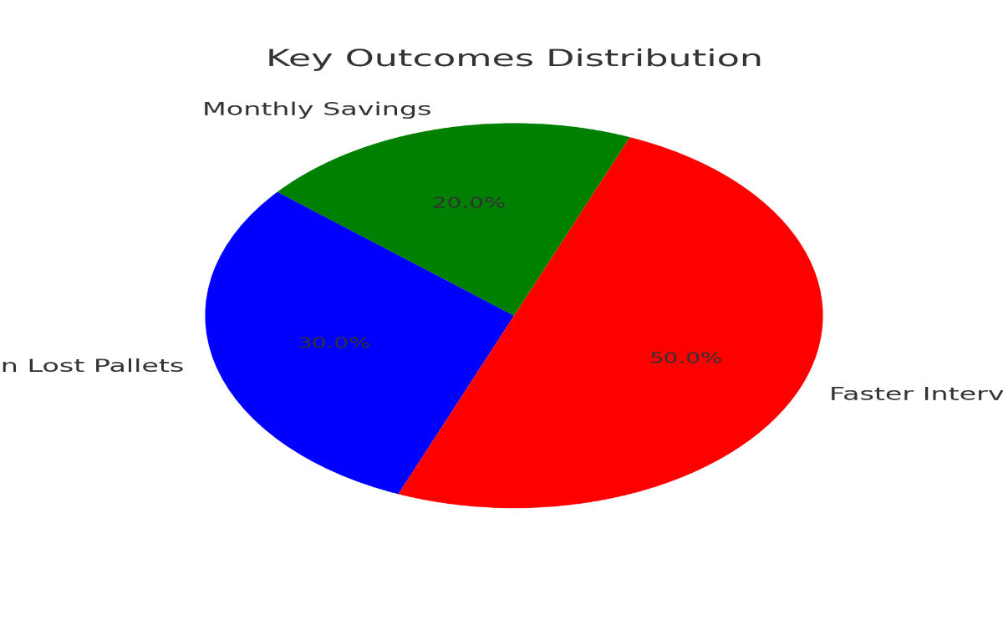

7.2 Scalability and Future Enhancements
- Scalability:
Current system handles 10,000+ pallets; architecture supports scaling to 100K+ with linear cost growth.
Edge-Cloud Hybrid Infrastructure:
Edge: Process critical alerts locally (e.g., GPS deviation checks) for sub-second latency.
Cloud: Centralize analytics and historical data for fleet-wide optimization.

- Future Enhancements:
Predictive Analytics:
Forecast high-risk routes using weather, traffic, and theft trends (e.g., 30% risk reduction in pilot zones).
Dynamic GPS Ping Frequency:
Adjust ping intervals based on pallet speed (e.g., every 1 min at >60 mph vs. 5 min at <20 mph).
AI-Driven "E-Pal":
Autonomous pallets with self-routing capabilities, reducing manual intervention by 50%.

